**Assignment 7**

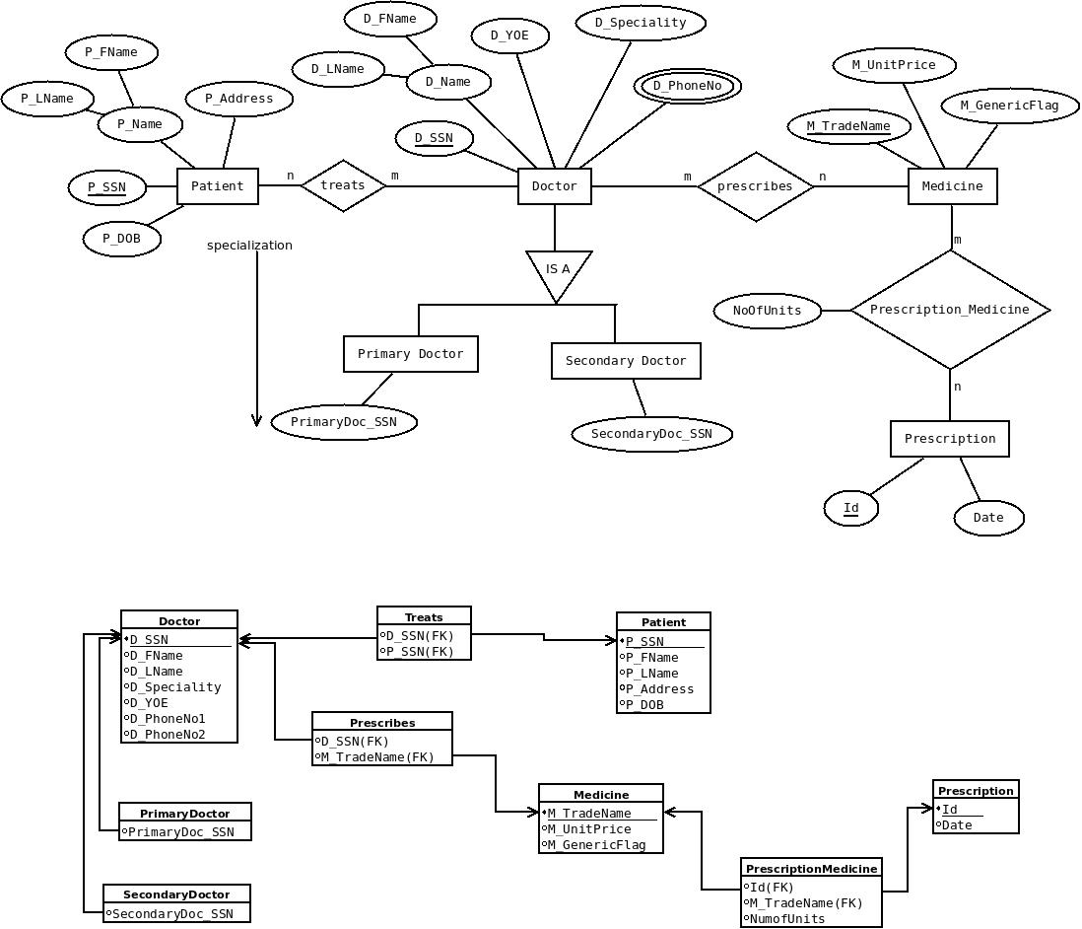

**Assumptions**

1. Many Doctor treats many patients. Hence m:n relationship
2. Many doctor prescribes many medicines. Hence m:n relationship
3. Doctor is specialized as Primary Doctor and Secondary Doctor
4. D_SSN, P_SSN, Id, M_TradeName are primary keys
5. Phone No of Doctor is a multivalued attribute
6. Name of Doctor and Patient is composite attribute

**SQL:**

CREATE TABLE DOCTOR (

DSSN VARCHAR2(10) PRIMARY KEY,

DFirstName VARCHAR2(50),

DLastName VARCHAR2(50),

Specialty VARCHAR2(20),

YOE INT,

PhoneNo VARCHAR2(15));

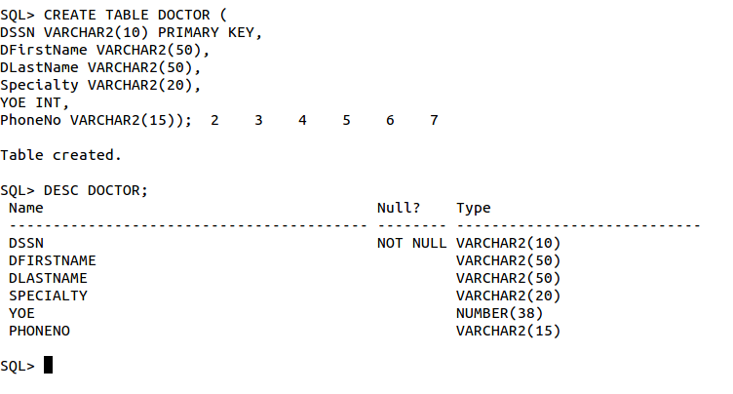

CREATE TABLE PATIENT (

PSSN VARCHAR2(10) PRIMARY KEY,

PFirstName VARCHAR2(50),

PLastName VARCHAR2(50),

Address VARCHAR2(25),

DOB DATE,

PrimaryDoctor_SSN VARCHAR2(10),

CONSTRAINT PFK1 FOREIGN KEY (PrimaryDoctor_SSN) REFERENCES

DOCTOR(DSSN) ON DELETE CASCADE);

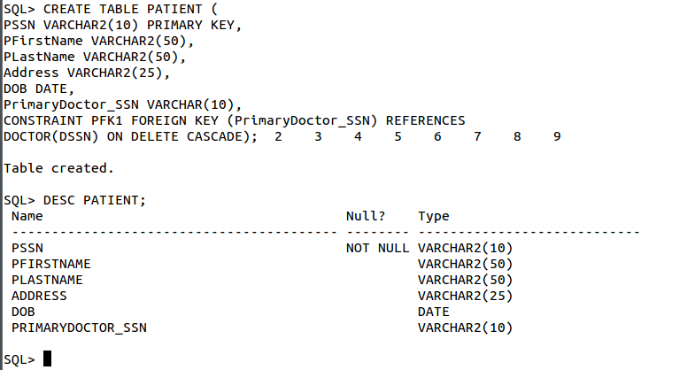

CREATE TABLE MEDICINE (

TradeName VARCHAR2(20) PRIMARY KEY,

UnitPrice NUMBER(10,2),

GenericFlag CHAR(1));

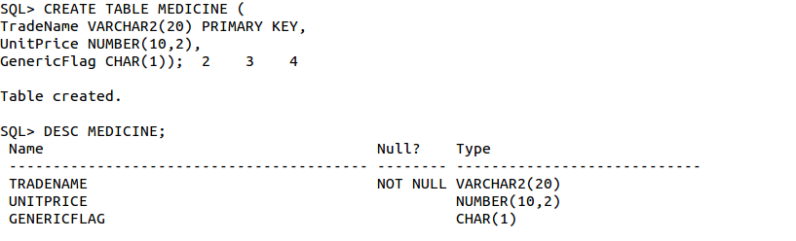

CREATE TABLE PRESCRIPTION (

ID VARCHAR2(10) PRIMARY KEY,

PDate DATE,

Doctor_SSN VARCHAR2(10),

Patient_SSN VARCHAR2(10),

CONSTRAINT PNFK1 FOREIGN KEY (Doctor_SSN) REFERENCES DOCTOR(DSSN)

ON DELETE CASCADE,

CONSTRAINT PNFK2 FOREIGN KEY (Patient_SSN) REFERENCES PATIENT(PSSN)

ON DELETE CASCADE);

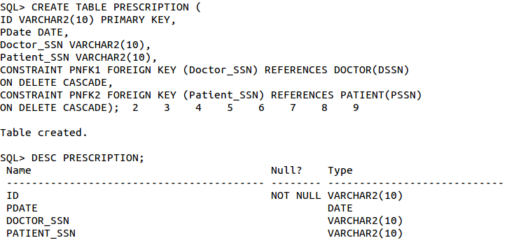

CREATE TABLE Prescription_Medicine (

Prescription_Id VARCHAR2(10),

TradeName VARCHAR2(20),

NumOfUnits NUMBER,

CONSTRAINT PMFK1 FOREIGN KEY (Prescription_Id) REFERENCES

Prescription(ID) ON DELETE CASCADE,

CONSTRAINT PMFK2 FOREIGN KEY (TradeName) REFERENCES

Medicine(TradeName) ON DELETE CASCADE);

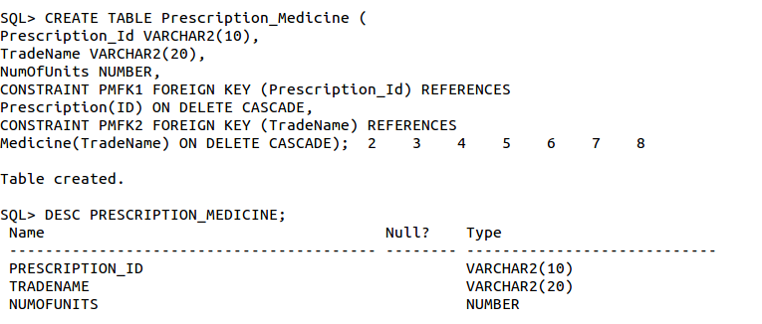

CREATE TABLE TREATS (

DSSN VARCHAR2(10),

PSSN VARCHAR2(10),

CONSTRAINT TRFK1 FOREIGN KEY (DSSN) REFERENCES DOCTOR(DSSN),

CONSTRAINT TRFK2 FOREIGN KEY (PSSN) REFERENCES PATIENT(PSSN));

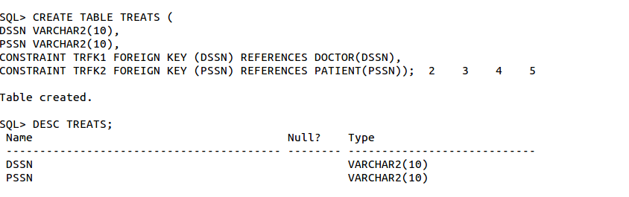

INSERT ALL

INTO DOCTOR VALUES ('123456789', 'Ajay', 'Kumar', 'Cardiology', 15, '123-456-7890')

INTO DOCTOR VALUES ('234567890', 'Jaya', 'Das', 'Pediatrics', 10, '234-527-8401')

INTO DOCTOR VALUES ('345678901', 'Swastika', 'Jha', 'Orthopedics', 20,

'345-678-9012')

INTO DOCTOR VALUES ('456789012', 'Vartika', 'Roy', 'Oncology', 8, '456-715-0123')

INTO DOCTOR VALUES ('567890123', 'Harsh', 'Singh', 'Internal Medicine', 12,

'567-890-1234')

SELECT * FROM dual;

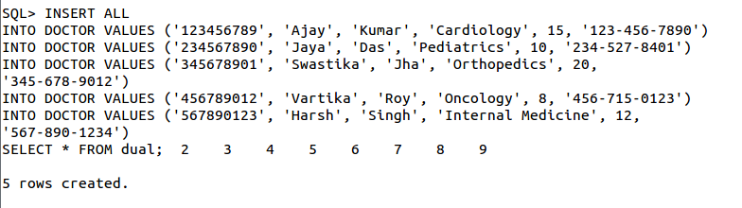

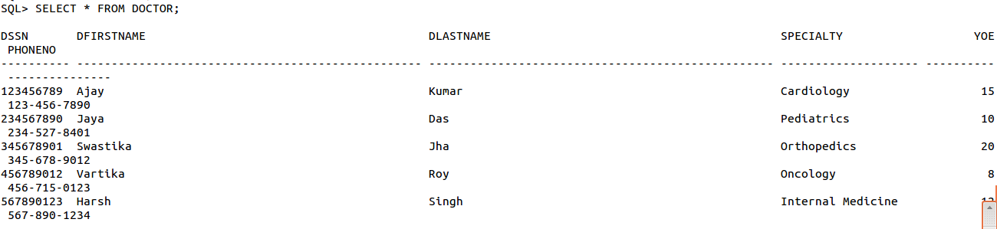

INSERT ALL

INTO PATIENT VALUES ('111111111', 'Aditya', 'Kumar', 'Karunamoyee',

TO_DATE('1990-05-15', 'YYYY-MM-DD'), '123456789')

INTO PATIENT VALUES ('222222222', 'Divya', 'Dutta', 'Howrah',

TO_DATE('1985-08-20', 'YYYY-MM-DD'), '234567890')

INTO PATIENT VALUES ('333333333', 'Suman', 'Aggarwal', 'Bally',

TO_DATE('1975-12-10', 'YYYY-MM-DD'), '345678901')

INTO PATIENT VALUES ('444444444', 'Jatin', 'Sharma', 'Barrackpore',

TO_DATE('2000-03-25', 'YYYY-MM-DD'), '456789012')

INTO PATIENT VALUES ('555555555', 'Kajal', 'Kumari', 'Liluah',

TO_DATE('1998-09-30', 'YYYY-MM-DD'), '567890123')

SELECT * FROM dual;

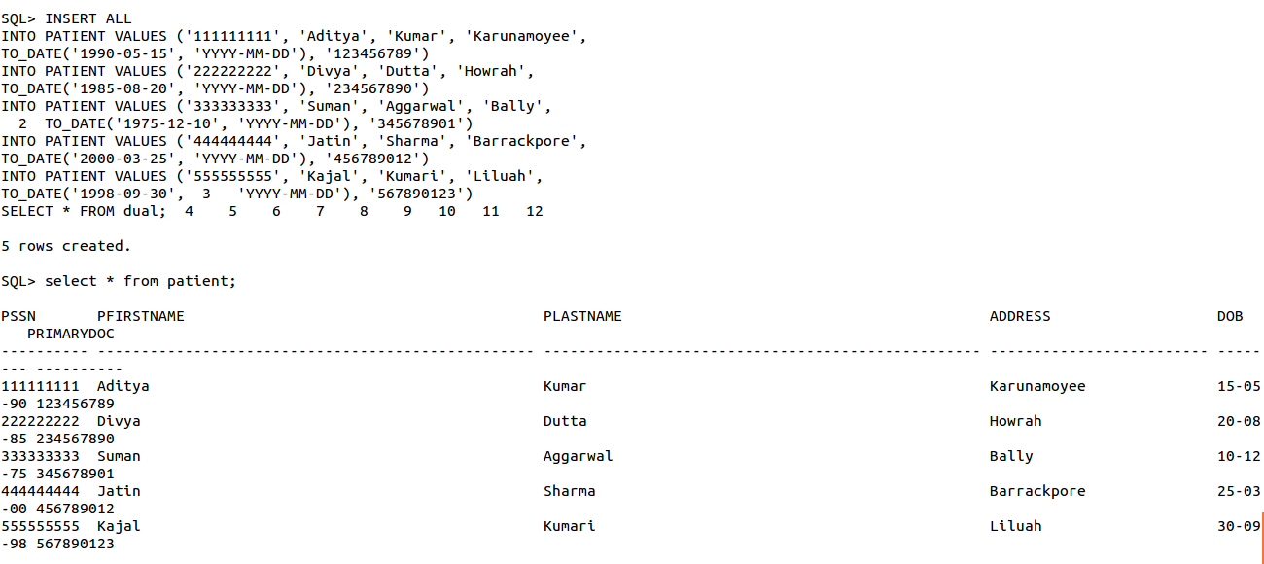

INSERT ALL

INTO MEDICINE VALUES ('Crocin', 10.00, 'N')

INTO MEDICINE VALUES ('Brufen', 5.00, 'N')

INTO MEDICINE VALUES ('Paracetamol', 15.00, 'Y')

INTO MEDICINE VALUES ('Amoxicillin', 20.00, 'Y')

INTO MEDICINE VALUES ('Ibuprofen', 8.00, 'Y')

SELECT * FROM dual;

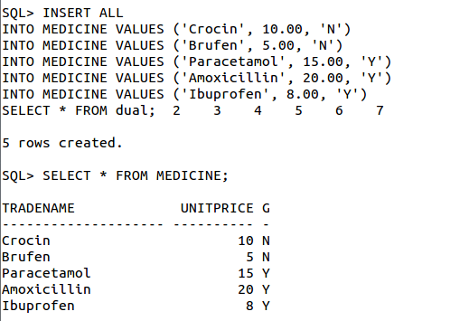

INSERT ALL

INTO PRESCRIPTION VALUES ('00001', TO_DATE('2024-03-19', 'YYYY-MM-DD'),

'123456789', '111111111')

INTO PRESCRIPTION VALUES ('00002', TO_DATE('2024-03-20', 'YYYY-MM-DD'),

'234567890', '222222222')

INTO PRESCRIPTION VALUES ('00003', TO_DATE('2024-03-21', 'YYYY-MM-DD'),

'345678901', '333333333')

INTO PRESCRIPTION VALUES ('00004', TO_DATE('2024-03-22', 'YYYY-MM-DD'),

'456789012', '444444444')

INTO PRESCRIPTION VALUES ('00005', TO_DATE('2024-03-23', 'YYYY-MM-DD'),

'567890123', '555555555')

SELECT * FROM dual;

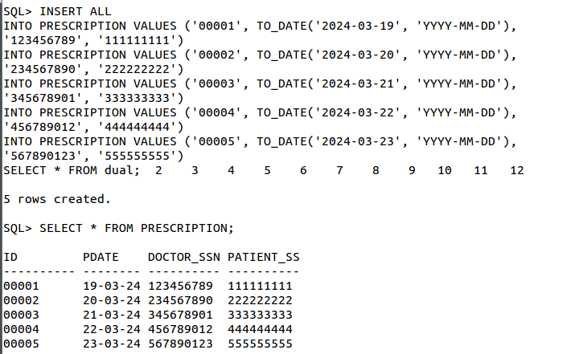

INSERT ALL

INTO Prescription_Medicine VALUES ('00001', 'Crocin', 2)

INTO Prescription_Medicine VALUES ('00002', 'Brufen', 1)

INTO Prescription_Medicine VALUES ('00003', 'Paracetamol', 3)

INTO Prescription_Medicine VALUES ('00004', 'Amoxicillin', 2)

INTO Prescription_Medicine VALUES ('00005', 'Ibuprofen', 2)

SELECT * FROM dual;

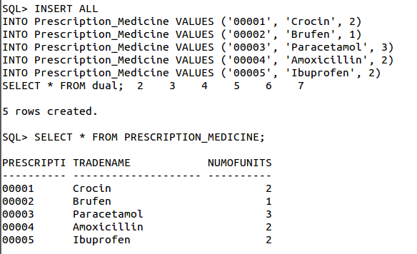

**QUERIES:**

**1.** List the trade name of generic medicine with unit price less than $50.

SELECT TradeName

FROM MEDICINE

WHERE GenericFlag = 'Y' AND UnitPrice < 50;

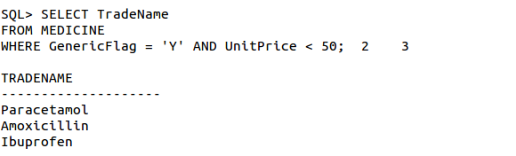

**2.**  List the first and last name of patients whose primary doctor named 'John Smith'.

INSERT INTO DOCTOR VALUES ('678901234', 'John', 'Smith', 'Pediatrics', 6, '897-654-0125');

INSERT INTO PATIENT VALUES ('666666666', 'Anup', 'Raj', 'Behala',

TO_DATE('1996-05-30', 'YYYY-MM-DD'), '678901234');

SELECT p.PFirstName, p.PLastName

FROM PATIENT p

JOIN DOCTOR d ON p.PrimaryDoctor_SSN = d.DSSN

WHERE d.DFirstName='John' AND d.DlastName='Smith';

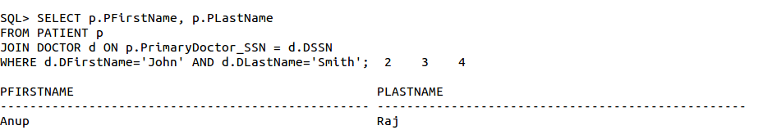

**3.** List the first and last name of doctors who are not primary doctors to any patient.

INSERT INTO DOCTOR VALUES ('678901234', 'Dave', 'Smith', 'Pediatrics', 6, '897-654-0125');

SELECT DFirstName, DLastName

FROM DOCTOR

WHERE DSSN NOT IN (SELECT PrimaryDoctor_SSN FROM PATIENT WHERE

PrimaryDoctor_SSN IS NOT NULL);

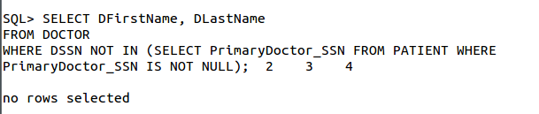

**4.** For medicines written in more than 20 prescriptions, report the trade name and the total number of units prescribed.

SELECT pm.TradeName, SUM(pm.NumOfUnits) AS TotalUnits

FROM Prescription_Medicine pm

GROUP BY pm.TradeName

HAVING COUNT(pm.Prescription_Id) > 20;

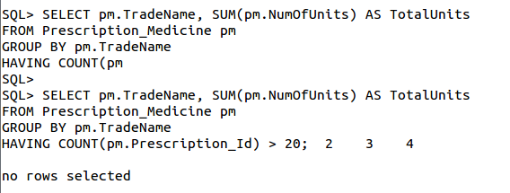

**5.** List the SSN of patients who have ʻCrocinʼ and ʻParacetamolʼ trade names in one prescription.

SELECT p.PSSN

FROM PATIENT p

JOIN PRESCRIPTION pr ON p.PSSN = pr.Patient_SSN

JOIN Prescription_Medicine pm ON pr.ID = pm.Prescription_Id

WHERE pm.TradeName IN ('Crocin', 'Paracetamol')

GROUP BY p.PSSN

HAVING COUNT(DISTINCT pm.TradeName) = 2;

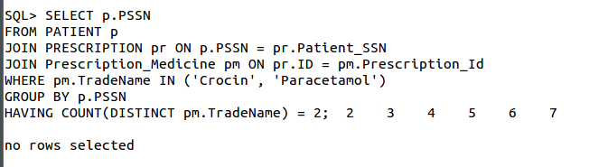

6. List the SNN of distinct patients who have ʻAspirinʼ prescribed to them by doctor named ʻJaya Das'.

SELECT DISTINCT p.PSSN

FROM PATIENT p

JOIN PRESCRIPTION pr ON p.PSSN = pr.Patient_SSN

JOIN DOCTOR d ON pr.Doctor_SSN = d.DSSN

JOIN Prescription_Medicine pm ON pr.ID = pm.Prescription_Id

WHERE pm.TradeName = 'Paracetamol' AND d.dFirstName = 'Jaya' AND d.DLastName = 'Das';

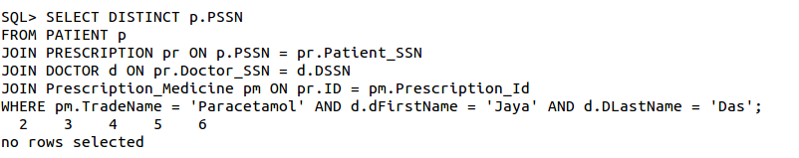

7. List the first and last name of patients who have no prescriptions written by doctors other than their primary doctors.

SELECT p.PFirstName, p.PLastName FROM PATIENT p WHERE NOT EXISTS (

SELECT * FROM PRESCRIPTION pr

JOIN DOCTOR d ON pr.Doctor_SSN = d.DSSN

WHERE pr.Patient_SSN = p.PSSN AND pr.Doctor_SSN <> p.PrimaryDoctor_SSN);

